**PROJECT REPORT**

**on**

**Android 2d gaming application**

**(CSE IV Semester Mini project )**

**2020-2021**



**Submitted to: Submitted by:**

Ms. Preeti Chaudhary Mr. Meghwant singh

(CC-CSE-E-IV-Sem) Roll. No.:1918469

**Guided by:** CSE-E-V-Sem

Mr. Avnish Panwar Session: 2020-2021

(Resource Person)

**DEPARTMENT OF COMPUTER SCIENCE AND INFORMATION TECHNOLOGY**

**GRAPHIC ERA HILL UNVERSITY, DEHRADUN**

**CERTIFICATE**

Certified that Mr. Meghwant Singh (Roll No.- 1918469) has developed mini project on “Android 2d gaming appliaction” for the CS IV Semester Mini Project Lab in Graphic Era Hill University, Dehradun. The project carried out by Students is their own work as best of my knowledge.

Date: 12/5/2021

( Ms. Preeti Chaudhary )

**Project Co-ordinator**

**CC-CSE-E-IV-Sem**

(CSE Department)

GEHU Dehradun

**ACKNOWLEDGMENT**

We would like to express our gratitude to The Almighty Shiva Baba, the most Beneficent and the most Merciful, for completion of project.

We wish to thank our parents for their continuing support and encouragement. We also wish to thank them for providing us with the opportunity to reach this far in our studies.

We would like to thank particularly our project Co-ordinator Ms. Preeti Chaudhary and our Project Guide Mr. Avnish Panwar for his patience, support and encouragement throughout the completion of this project and having faith in us.

At last but not the least We greatly indebted to all other persons who directly or indirectly helped us during this work.

**Mr. MEGHWANT SINGH**

**Roll No.- 1918469**

**CSE-E-IV-Sem**

**Session: 2020-2021**

**GEHU, Dehradun**

**TABLE OF CONTENTS**

**CHAPTER NO. TITLE**

**1. INTRODUCTION**

1.1 ABOUT PROJECT

1.2 ABOUT ANDROID 2D GAMING

1.3 BASIC REQUIREMENT FOR PROJECT

**2. PROJECT METHODOLOGY**

2.1 TIC TAC TOE GAME APPLICATION

2.2 WORKING OF GAME

**3. SNAPSHOT OF PROJECT RESULT**

3.1 TIC TAC TOE FINAL RESULT ON DEVICE

**4. ABSTRACT**

**REFERENCE**

**CHAPTER** **1**

**INTRODUCTION**

* 1. **ABOUT PROJECT**

As the title suggests, in this project is about an android 2d gaming application in which i have developed a “TIC-TAC-TOE”, which can play whenever you feel bored and can be played anywhere. You just need 2 peoples to play and enjoy. This game has very easy rules. It is also known as X’s and O’s. The player who wants to win, one has to get three same either X’s or Os in a row- horizontally, vertically, diagonally, otherwise gets a tie.

**1.2 ABOUT ANDROID 2D GAMING**

An electronic game played using a cellular phone. A mobile game is a game played on a mobile phone (feature phone or smart phone), tablet, PDA, portable media player or graphing calculator.2D games, as their name suggests, are titles with only two axes of motion.Example of some android 2d games are :Gold Digger , Ludo etc.

**1.3 BASIC REQUIREMENT**

1. ANDROID STUDIO : Android Studio is the official integrated development environment (IDE) for Google's Android operating system, built on Jet Brains IntelliJ IDEA.

Version used in project : Version 4.2 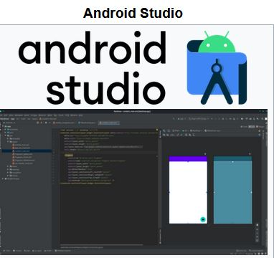

## Features of Android studio:

* Gradle -based build support
* Android-specific refactoring and quick fixes
* Lint tools to catch performance, usability, version compatibility and other problems.

2. BASIC SYSTEM REQUIREMENT :

For project I have use window 10 with 4gb GEFORCE GTX graphics.

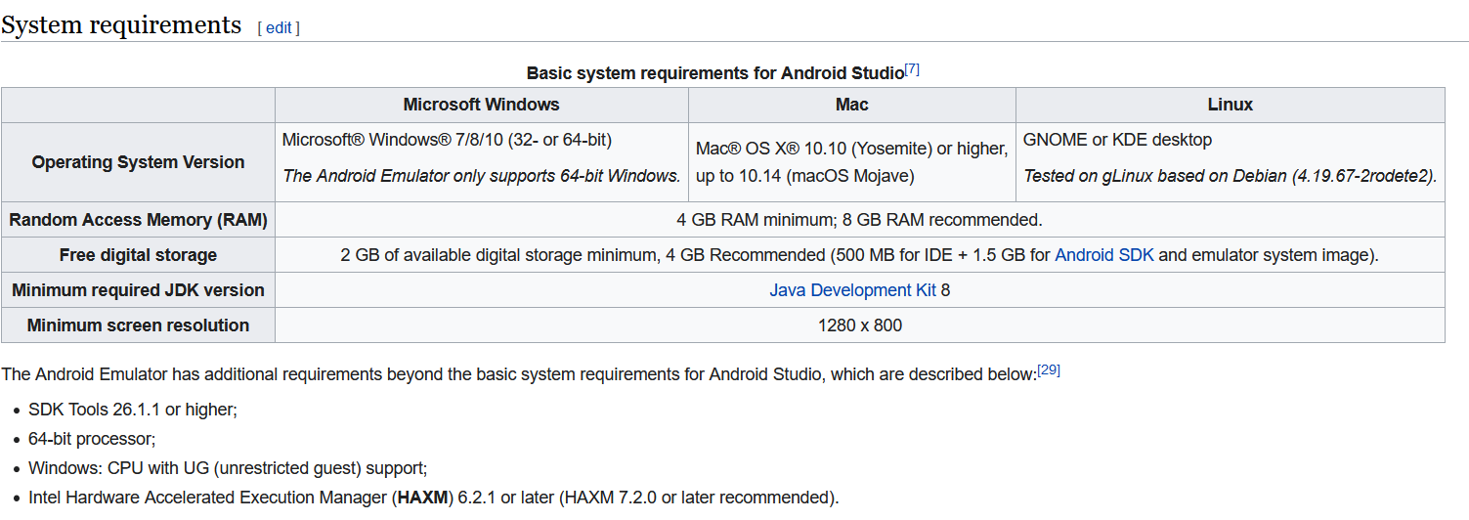

3. JAVA ANDROID PACKAGE :

Java is primarily used in Android games these days, simply because it's the primary language for that platform. Given in source code. Some of them are-

import androidx.appcompat.app.AppCompatActivity;  
import android.os.Bundle;  
import android.view.View;

**CHAPTER** **2**

**PROJECT METHODOLOGY**

In this chapter we will discuss about the requirement of the projects and the functions used with it’s purpose and other things as well like flowcharts, working.

**2.1 TIC TAC TOE GAME APPLICATION**

Tic-Tac-Toe is a simple and fun game for 2 players, X and O. It is played on a 3x3 grid. Each player's goal is to make fill 3 three box with same element in a particular order .

FORM WHERE I START MAKING TIC TAC TOE GAME APPLICATION

Step to make this game app:

Step 1: Using Android Studio which is integrated development environment is a software on which we created an empty project and given the name “Tic Tac Toe”.

Step 2: Then basic folders for the project are created automatically .Then I start creating the basic xml file for framework for app like background , buttons ,text view and links.

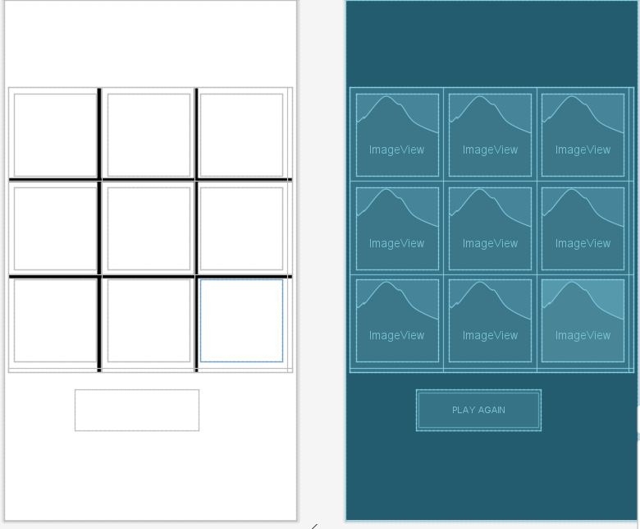 fig : Game background work adding buttons

Step 3: In java folder we have main activity file in which we have java code for basic tic tac toe game.

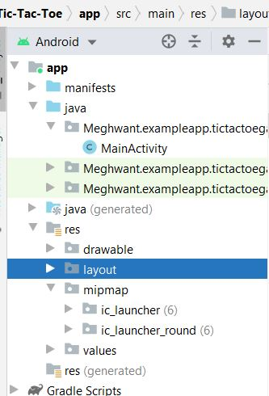 fig : File and folder created

Step 4: Now for testing the app I have to use emulator we have make hello named emulator which is a basic smart phone.

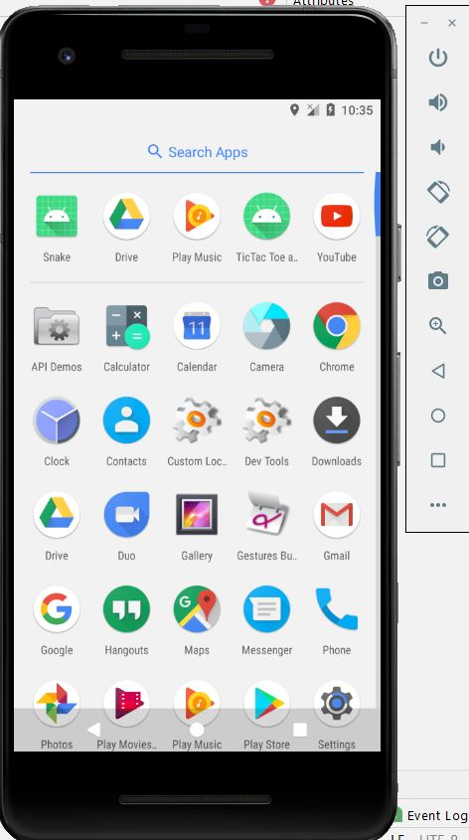 Fig : Basic smart phone emulator

Step 6: At the end we are able to play game .

**2.2 WORKING OF GAME**

This game app can be played by only 2 players, the one who wants to win this game has to fulfill some conditions :

* The one has to get three same either Xs or Os in a straight line/row – diagonally, vertically, horizontally.
* And as this game is a 2-player game then the player should get the 2 different markers to play with their consecutive turns i.e. one by one, which means the markers need to be change after every execution.
* And by mistake if the player chooses the marker which has been chosen already, then the turn should not be removed, for which we have to go back to re-execute the turn of that player.
* And at last, if the game gets a tie, it should get exit automatically or the execution should terminate at that moment.

BAISC FLOW CHART :

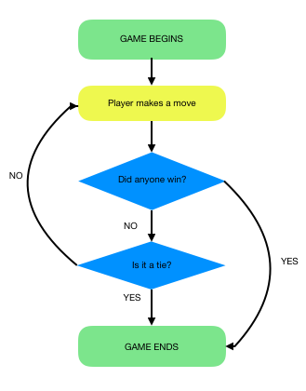 LOGIC AND CODE BEHIND GAME :

* The game is played on a grid that's 3 squares by 3 squares.
* You are X, your friend is O. Players take turns putting their marks in empty squares.
* The first player to get 3 of her marks in a row (up, down, across, or diagonally) is the winner.
* When all 9 squares are full, the game is over. If no player has 3 marks in a row, the game ends in a tie.

Location used in k-map for game

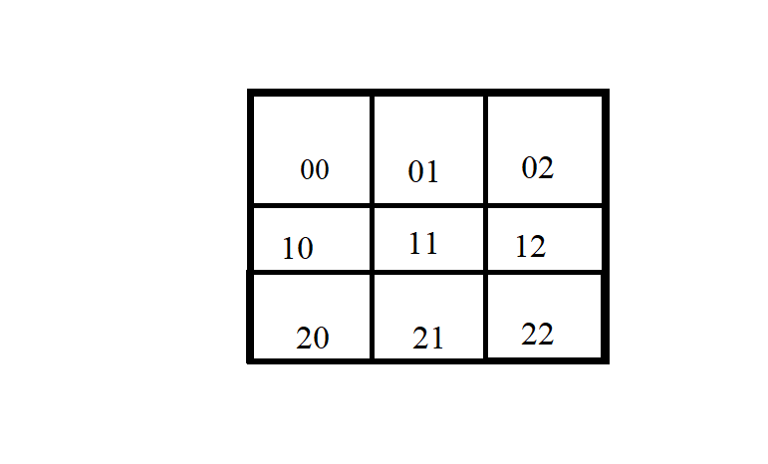

Code : for checking the win condition

**if** (**games**[wp[0]] == **games**[wp[1]] && **games**[wp[1]] == **games**[wp[2]] && **games**[wp[0]] != 2) {  
 String win = **""**;  
 **active** = **false**;  
 **if** (**r** == 1) {  
 win = **"X wins"**;  
 } **else** {  
 win = **"O wins"**;

}

Other then this game will be tie or game stop.

**CHAPTER** **3**

**SNAPSHOT OF PROJECT**

In this chapter we will look “How our game works diagrammatically, pics and final result of project ”.

*STARTING & PLAYING*

* How to start playing the game?

We just have to open the game and the one individual who will start playing (as player 1) has to choose his marker or sign (either ‘X’ or ‘O’) and the system or compiler will fix his marker for that particular game, when the game ends they can swap their markers if they want. For ex. If player A has ‘X’ marker and player B has ‘O’ marker when the game ends if they want, they can swap their markers and turns as well .

After choosing marker the first player has to press ‘ENTER’ to start the game and they can start enjoying the game.

3.1 TIC TAC TOE FINAL RESULT ON DEVICE

 Fig : Contain Tic Tac toe app

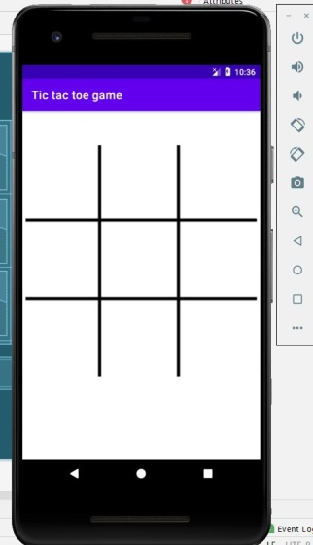 fig :Basic game starting screen

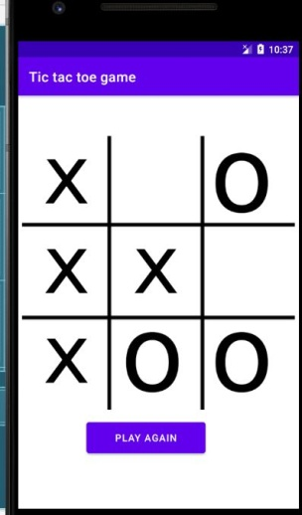 fig : At the end show Play again Button

Above all are final result of project .

**4. ABSTRACT**

In this project we have successfully created the Tic tac toe gaming app. TIC-TAC-TOE”, which can play whenever you feel bored and can be played anywhere. You just need 2 peoples to play and enjoy. This game has very easy rules. It is also known as X’s and O’s. The player who wants to win, one has to get three same either X’s or Os in a row- horizontally, vertically, diagonally, otherwise gets a tie.

Due to this project I am able to how to make an application .It is not an easy task ,I have face many challenges like gradle , run time exception , emulator not working and many more error but at the end I am able to completed my project in time. Tic tac toe is an easy ,joyful and logical game which help to develop your logic and under the working of a application and software like android studio etc.

**REFERENCE**

* Websites:

3.1 GEEKSforGEEKS.org

3.2 Programiz.com

3.3 Begginersbook.com

3.4 Learncpp.com

* You tube.
* Wikipedia : https://en.wikipedia.org/wiki/Android_Studio